

**MINISTRY OF ENVIRONMENT AND NATURAL RESOURCES**

**STATE DEPARTMENT OF ENVIRONMENT**

**REPORT**

**ON**

**THE ROLE OF MASS COMMUNICATION AND JOURNALISM IN CHEMICALS MANAGEMENT IN THE ENGLISH SPEAKING AFRICAN COUNTRIES**

**HELD AT**

**BURGERS PARK HOTEL, PRETORIA, SOUTH AFRICA**

**FROM**

**13TH -15TH SEPTEMBER, 2017**

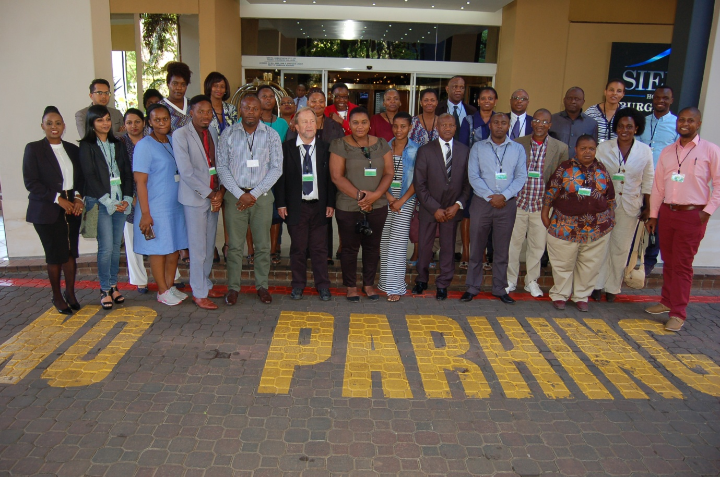

A group photograph of the participants at Burgers Park Hotel in Pretoria, South

Africa

**1.0 Overview**

The Africa Institute in collaboration with the Swedish Chemical Agency (KEMI)

Organized a regional workshop for journalists and communication experts from selected English speaking African countries, on the role of Mass Media and Journalism in Chemicals Management at Burgers Park hotel in Pretoria, South Africa.

Chemicals form a significant part of our everyday life as we are exposed to them in many daily activities. However, very few citizens have knowledge on the risks involved and how to protect themselves. To create awareness on chemical management and call communities to action, protect the environment and help reverse the damages caused by hazardous chemicals, the media was seen as the most appropriate medium to reach citizens using its various platforms. The workshop was therefore meant to help position the media to take that responsibility and make participants deliver heightened attention on issues of environmental protection and preservation.

* 1. **Objectives**

1. To bring together participants from various relevant government sectors of Environment, Labour, Health, and/or Agriculture agencies from the 10 selected African countries;
2. To increase appreciation and understanding on the role of mass media and journalism in chemicals implementation; and
3. To provide an opportunity to share experiences and learn best practices from the continent and beyond.

**1.2 Participants**

Participants were drawn from 9 African countries namely: Botswana, Kenya, Lesotho, Mauritius, Namibia, Swaziland, South Africa, Tanzania and Zambia.

Kenya had five (5) participants drawn from the State Department of Environment, National Environment Management Authority (NEMA) and Kenya News Agency (KNA). In total, 29 participants attended the workshop.

**2.0 Methodology**

The training was facilitated by the African Institute and Swedish Chemical Agency (KEMI) and coordinated by Dr. Koebu Khalema. The mode of teaching was mainly plenary lecture presentations and question and answer sessions on the topic of discussion.

**3.0 Workshop Programme**

**Day 1, Wednesday 13th September, 2017**

**3.1 Opening Remarks** **by Dr. J. Molapisi, Director General of African Institute**

Dr. Molapisi welcomed participants to the workshop and informed them that training was one of the Institutes’ core mandates to build capacity for governments and countries in Africa to address debilitating effects of poor chemicals management and thereby creating a more habitable environment in the continent. He noted that the training was also a critical milestone in the Institute’s quest to create a hazardous free environment throughout the continent. This, he said is an enormous responsibility that can only be achieved through joint efforts. He singled out the media as one of their critical stakeholders given its role in educating and sensitizing the society.

In his presentation, Dr. Molapisi quoted Malcolm X who said ‘the media is the most powerful entity on earth. They have the power to make the innocent guilty and to make the guilty innocent and that’s power, because they control the minds of the masses’. He observed that it is time to tap that power to sensitize society on the effects of hazardous chemicals in the environment and to galvanize communities to take action, protect the environment and help reverse the damages caused by hazardous chemicals. He noted that information on the dangers of our actions to the environment and what mitigating actions are required to preserve it for future generations should be among the media priorities. He added that the media cannot continue to ignore these important and life threatening effects.

He explained that together with KEMI, the Institute decided to host this workshop as a way of empowering the media to begin to be vigilant and use its power to turn the tide against environmental destruction**.** He emphasized that given its influence in society, the media cannot be complicit to environmental degradation through its silence, neither can it continue its cooperation with those destroying precious life by not reporting their actions and thereby protesting against them.Dr.Molapisi concluded his remarks by saying that it is time media stopped being passive but instead get actively involved in efforts to reclaim and rebuild the environment.

**3.2 Background and Objectives: Chemicals in Society by Dr. K. Khalema**

Some of the highlights were:

1. An average individual appreciates and acknowledges the dangers of chemicals in society;
2. It is important to provide all citizens with information to protect themselves and reduce risks associated with chemicals at all levels;
3. All the 17 United Nations (UN) Sustainable Development Goal’s (SDG’s) are associated with chemicals and each country is required to develop and update a chemicals management profile and monitor and report to the public;
4. Citizens should be made to understand the risks and hazards of chemicals; For example, exposure to skin lightening creams and other daily utilities.
5. There is need to sensitize citizens on the signed International conventions of their respective countries and their implications, using packaged information in various forms like film, radio programmes and use local dialects to reach as many people as possible; and
6. The media has the responsibility to provide information to citizens on how much they are exposed to chemicals and how to protect themselves.

**3.3 STRATEGIC APPROACH TO INTERNATIONAL CHEMICALS MANAGEMENT (SAICM) and other global initiatives by Dr. Bengt Melsater**

Some of the key highlights of his presentation were:

1. With proper information, an average individual can acknowledge and appreciate the dangers of chemicals and e-waste;
2. There is need to raise capacity of all citizens to reduce risks associated with chemicals at all levels;
3. The roles of major stakeholders in chemical production, distribution and

management are key in chemicals management; and

1. Governments to identify monitor and report to the public on progress made on each of the 17 SDGs;

**3.4 The Role of Mass Media and Journalism in Chemicals by Mr Bengt Melsäter**

Key lessons from the presentation were:

1. Chemicals form an integral part of human life;
2. Chemicals are all around us, and are in every product we buy and it is therefore important to avoid risks to both human health and the environment;
3. It is imperative to disseminate Information and create awareness on chemicals and their dangerous properties and the risks involved when using them;
4. Internationally agreed system, Globally Harmonized System (GHS), for classification, labeling and Safety data sheets on a global level have been developed;
5. Media coverage on issues of chemical safety and chemicals management is very important;
6. Raise awareness among people exposed to dangerous chemicals;
7. Dissemination of information and sensitization of the general public, policy makers and political class is necessary;
8. Discussions in the workshop will add invaluable input to the development and improvement of awareness creation in chemicals risks in the society.

**Day 2 Thursday 14th September, 2017**

**3.5 International Instruments – Multilateral Environmental Agreements (MEAs) by Dr. K. Khalema**

Some of the highlights of the presentation were:

1. Instruments on chemicals and waste management conventions have been signed by member countries on the Basel, Stockholm and Rotterdam conventions (BSR);
2. Africa Institute helps countries to execute their signed conventions to protect

Citizens against hazardous waste;

1. The Institute also helps consolidate actions on health, environment and health of people and develop measures to mitigate against these risks under the (BSR) secretariat;
2. The conventions provide for listing subject to the 3 conventions and restricts

Production and use;

1. For the unintentionally produced pollutants, control of the activities of combustion is advised i.e. burning of coal, etc;
2. Every country has to monitor and report any information in their purview on these pollutants thus complying with the conventions;
3. Countries are required to domesticate the conventions according to the respective country laws and report progress;
4. That there are 28 listed world pollutants up from 12;
5. It is therefore imperative for countries to educate their citizens on the signed COPs for them to understand and protect themselves where necessary;
6. Countries to domesticate the signed treaties and if they have not, strategies should be put in place to publicize them and create awareness;
7. It is also important to provide knowledge and create awareness on chemical

Management since chemicals are found everywhere in our lives. For example, in petrol, electronic waste, toys, human contraceptives, etc;

1. For this to succeed, proper coordination and stakeholder engagement is vital

as this will ensure each stakeholder plays their role effectively; and

1. The media is very instrumental in this as it is capable of packaging and disseminating information for various audiences using suitable platforms.

**3.6 Chemical Safety Information and GHS- Key to Management by Dr. B. Melsater**

Some of the key highlights were**:**

1. The key issues are classification, labeling, data sheets and packaging;
2. It was noted that many people do not understand the meaning of labeling signs on chemical products;
3. It is therefore imperative to enhance chemical information through activities and regulations;
4. This can be done through; content development, capacity building for editors; branding of chemical reporters; mainstreaming chemical information in the school curriculum; educating and sensitizing the public on the dangers of chemicals and how to handle them; educate the public to understand the labels on the products; and provide them with information on the regulations, what should and should not be done and how to protect themselves;
5. The media can play this role very effectively if they are facilitated to do so;
6. They can use various strategies like: infomercials, promos, website, advertorials, squeeze backs, (reduce screen as you run your advert and still continue with the programme), establishment of environmental news desks in newsrooms, environmental award in chemical management reporting, mainstream chemical management issues in press releases where appropriate, share ideas on social media platforms and run taglines on pay slips, calendars, use bulk smses, among others.
7. If these and many more strategies are used, chemical management will be a common denominator in homes, schools, work places, churches and even social places and this will make it easy to introduce more information that will catch the attention of the masses.

**3.7 Case Study**

**The Role of Mass Media in society: Communication and Journalism**

**By an Invited Guest from MISA- Mr. Mpumelelo Mnisi**

Some of the key learnings of the presentation were:

1. Mr. Mnisi gave a brief introduction on MISA- Media Institute of Southern Africa;
2. He said it is a secretariat formed 10 years ago to realize the goals of the Windhoek declaration;
3. It was to work closely with editors in all media houses to create a variety of

Media freedoms and diversity, editorial independence and pluralism in the region;

1. He also shared some of the challenges they have faced such as; lack of media friendly laws, lack of professionalism; lack of editorial independence, etc;
2. He also shared some of the successes i.e. the institute has managed to organize for short courses for journalists in the region, fought to promote citizen participation in their programmes; and formed advocacy groups for social pursuit;
3. He reiterated the Media’s responsibility as the society’s watch dog and has to perform its role effectively.

**Day 3, Friday 15th September, 2017**

**4.0 Recommendations**

After intensive deliberations, the participants came up with the following

recommendations that are expected to change the chemicals management systems in

their respective countries if they are implemented.

|  |  |  |
| --- | --- | --- |
| RECOMMENDED /ACTIVITY | HOW/STRATEGY | WHO/ACTOR (S) |
| Awareness and Education | Through media- newspapers,  TV , radio, website, social  media, Bulk SMSs  To target internal publics | Communication  specialists, journalists  and NGOs |
| Continuous engagement of the media | Involving the media by using  various media platforms i.e  Running continuous  programmes by engaging  various stakeholders  (call ins, documentaries…  attractive programmes,  promotions, campaigns..  squeeze backs, talk shows,  jinggles, adverts etc | TV stations, Radio both  community and  national, print media  and line experts.  Communication  specialists |
| Capacity building /Training | Organize workshops or  breakfast meetings with  media practitioners to create  rapport and sell chemicals  management agenda | Media Associations , get  an environmental  expert and facilitator |
| Awards | Incentives to journalists on  coverage of topics on  environment (specifically on  chemicals) | Apex media body ie. MCK |
| Engagement meetings | Intensify stakeholder  engagements for awareness  creation | Media organizations/ |
| Advertorials | Relevant institutions to  package the information they  want out there in the way  they want i.e through  Supplements, | Environment agencies,  Ministries, NGOs,  Companies |
| Advocacy | Dedicated pages in the  newspapers especially print…  either daily or weekly (involve  editors and programmers)  supplements | NGOs. Media houses |
| Partnerships | Identify strategic partners to  work with and the medium to  use. | KEMI, MISA, MCK and others |
| Network  of Environmental journalists | Come up with a forum for  journalists for not only sharing  but engaging regionally on  matters of chemical  management | Africa institute |

Appendix 1: List of participants

|  |  |  |  |  |
| --- | --- | --- | --- | --- |
| No | Title | NAME | COUNTRY | Email |
| 1. | Mr. | Modise  Maphanyane | Botswana | maphs53@yahoo.com |
| 2. | Ms. | Tshepiso  Kadibadiba | Botswana | tbatlhapi@gov.bw |
| 3. | Ms. | Onalenna Dube | Botswana | Ounadianah@yahoo.com |
| 4. | Ms. | Lindiwe Letsholo | Botswana | lnletsholo@gov.bw |
| 5. | Mr. | Baboloki Semele | Botswana | rrebabolokisemele@gmail.com |
| 6. | Mr. | Njeru Elias Ngare | Kenya | njerungare@gmail.com |
| 7. | Ms. | Ndirangu Mary  Wangari | Kenya | Mawandi7@gmail.com |
| 8. | Ms. | Agnes Kamiri | Kenya | AKamiri@nema.go.ke |
| 9. | Ms. | Caroline Musasia | Kenya | cmusasia@gmail.com |
| 10. | Ms. | Eustus Kimani | Kenya | eustusk@gmail.com |
| 11. | Ms. | Motanyane  Kekeletso Evelyn | Lesotho | kekemotanyane@gmail.com |
| 12. | Mr | Matsasa Tsebo  Clement | Lesotho | [misalesotho@gmail.com](mailto:misalesotho@gmail.com) |
| 13. | Ms. | Rammoko  Mathato | Lesotho | mathatorammoko@gmail.com |
| 14. | Mr. | Aubrey  Chikungwa | Malawi | aubrey_chikungwa@yahoo.com |
| 15. | Mrs. | Bibi Yashria  Korimboccus | Mauritius | smohabuth@govmu.org |
| 16. | Ms. | Ujoodha  Roupeshna | Mauritius | roupeshna@gmail.com |
| 17. | Ms. | NakaleLigame  Albertina | Namibia | anakale@nepc.com.na |
| 18. | Ms. | Nafuka  Twapandula July | Namibia | julyjunafuka@gmail.com |
| 19. | Mr. | Vilho Muronga  Absalom | Namibia | Absalom.Vilho@met.gov.na |
| 20. | Mr. | Hlatshwayo  Vuyisile  Sikelela | Swaziland | Vuyisile62@yahoo.com |
| 21. | Mr. | Mnisi Mphumelelo  Thomas | Swaziland | mnizlz2000@yahoo.com |
| 22. | Ms. | Mhlanga Belusile  Marcia | Swaziland | belusile@sea.org.sz |
| 23. | Ms. | Sapanjo Monica  Maurice | Tanzania | ladymonsa@yahoo.com |
| 24. | Mr. | Godfrey Nago | Tanzania | gnago2002@yahoo.co.uk |
| 25. | Ms. | Lugoe Rachel  Obadia | Tanzania | lugoerachel@hotmail.com |
| 26. | Mr. | Gasirigwa G.S | Tanzania | misatanzania@gmail.com |
| 27. | Ms. | Zulu Mercy | Zambia | mzulu@zema.org.zm |
| 28. | Mr. | Zulu Thomas | Zambia | Thomas2008@gmail.com |
| 29. | Mr. | Tembo Benedict  Kanjombe | Zambia | bt@daily-mail.co.zm |